2.E. The OSDT Android SensorPod: A smart controller for wireless sensor networks

The integration of mobile and cloud-computing infrastructure represents a disruptive technology in the field of environmental science, since basic assumptions about technology requirements are now open to revision. It allows established facilities to plan graceful migrations as they adapt to inevitable technological change, and the immediate effects may be more apparent in communities and countries where existing infrastructure is limited, as is the case in many developing countries. Wireless sensor networks and virtualization of data and network services is the future of environmental science infrastructure. The OSDT Android SensorPod was designed with these considerations in mind.

The OSDT SensorPod is a custom-designed mobile computing platform for assembling wireless sensor networks as part of environmental monitoring applications. Funded by an award from the Gordon and Betty Moore Foundation, the University of California, San Diego’s OSDT SensorPod represents a significant technological advance in the application of mobile and cloud computing technologies for near-real-time applications in environmental science, natural resources management, and disaster response and recovery. It provides a modular architecture based on open standards and open-source software that allows system developers to align their projects with industry best practices and technology trends. It also allows researchers to avoid being locked into expensive proprietary software and hardware systems. The OSDT Android SensorPod is managed as an open source project within the UCSD Open Source DataTurbine Initiative ([www.dataturbine.org](http://www.dataturbine.org)). As such, it depends on the generous contributions of a broad international community of users and developers.

**SensorPod Assembly and Applications**

The OSDT Android Sensor pod was designed to be relatively quick and easy to assemble from common and inexpensive commodity products.

|  |
| --- |
|  |

Components in the OSDT Android SensorPod package

|  |  |
| --- | --- |
|  |  |
|  |  |

An assembled OSDT Android SensorPod (without the Droid phone/tablet) side view, and connected with a Vaisala WXT 520 weather station and Android smart phone.

The OSDT Android SensorPod has been connected with various sensors and deployed in a variety of environments for diverse environmental monitoring applications, including lakes, forests, and oceans. It has demonstrated its stability with a six-month run at the Scripps Pier in UCSD and a four-month run at Sparkling Lake in Wisconsin. Furthermore, as noted in the section on Building Community, it has been designed for ease-of-construction, and others have assembled it and deployed it at partner sites in Thailand and Taiwan.

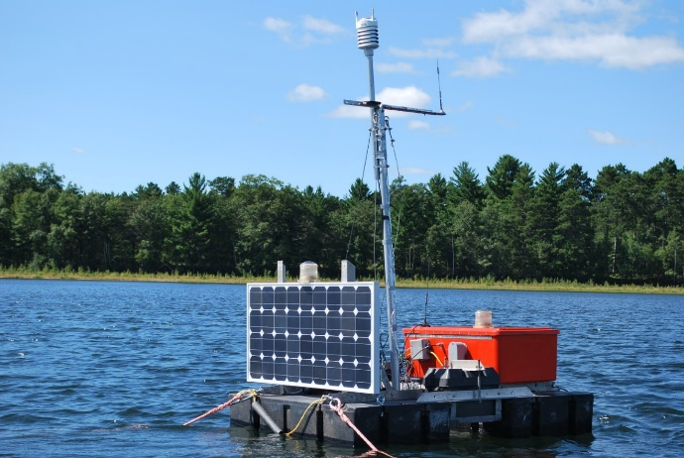

The OSDT Android SensorPod deployed on a lake buoy in Wisconsin, USA. The OSDT Android SensorPod is inside the orange box. There are underwater sensors beneath the buoy and additional sensors above water (the weather station at the top of the pole). Data is sent via cell signal to a DataTurbine server running in the Amazon.com EC2 cloud. This system was deployed in 2012 and 2013, and used in an experiment to manage invasive species in a lake in Wisconsin.

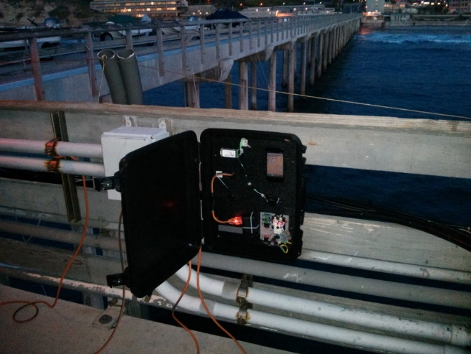

This OSDT Android SensorPod is deployed at the pier at the Scripps Institution of Oceanography, UC San Diego, CA, USA. This SensorPod uses SeaBird inductive modem technology to communicate with underwater pH sensors. Data is sent via cellular signal to a DataTurbine server running in the Amazon.com EC2 cloud. This is the first step in a possible wider deployment to measure ocean acidity around coral reefs.

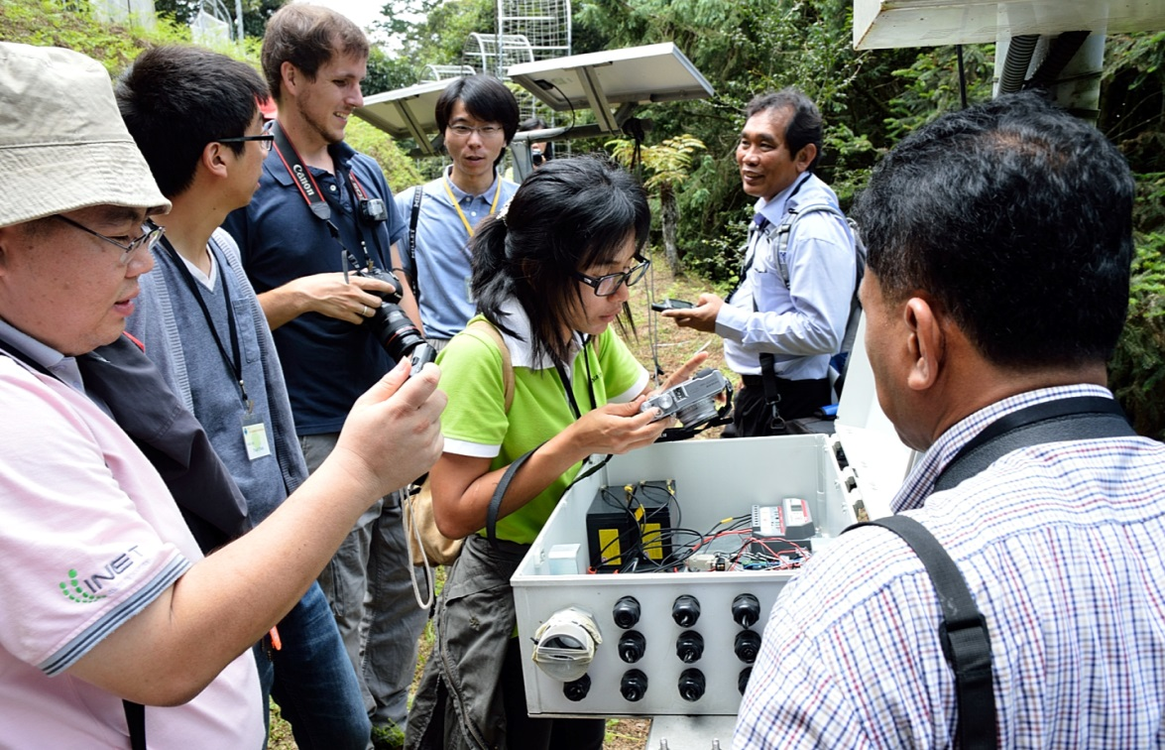

This OSDT Android SensorPod is mounted inside the open white box at the Medical Plant Garden at Lienhuachih Research Station in Taiwan. It is powered by solar panels and communicates via Wi-Fi to a DataTurbine server at the TFRI station.

The SensorPod deployment at the medical plant garden is part of a larger TFRI-observing system for studying biodiversity, climate change, and phenology in a forest environment. TFRI staff and UCSD students installed this OSDT Android SensorPod deployment on August 13, 2012. This deployment included a Vaisala WXT 520 meteorological station with sensors for air pressure, humidity, temperature, rainfall, wind direction, and wind speed. Two new sensors for monitoring solar radiation and fuel moisture will be integrated into the Medical Plant Garden SensorPod this summer as part of a project to model forest fire potential.

For more activities related to OSTD SensorPod, see both *Community Building* and *PRIME* sections.

Participants: UCSD: Tony Fountain, Peter Shin, Thaddeus Trihn (PRIME 2013), Sameer Tilak, and Ariana Tsai and Sara Taghizadeh (both PRIME 2012); U Texas El Paso, Gesuri Ramirez; Erigo Technologies: John Wilson; Cycronix: Matt Miller; TFRI: Chau-Chin Lin, Yu-Huang Wang, Sheng-Shan Lu; U Wisconsin: Tim Kratz, Tim Meinke, Ken Morrison, Jordan Reed; SIO: Jennifer Smith, Nichole Price, Susan Kram.